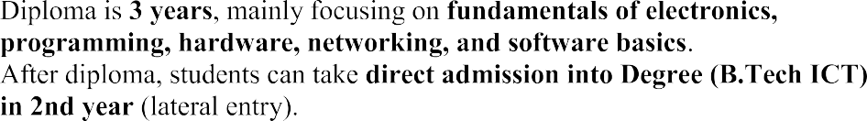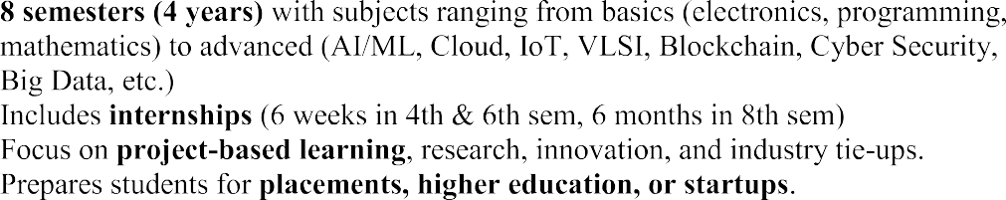  

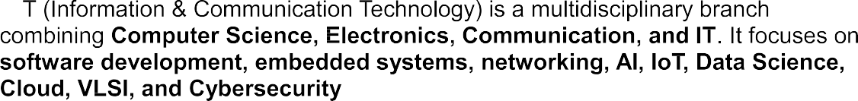

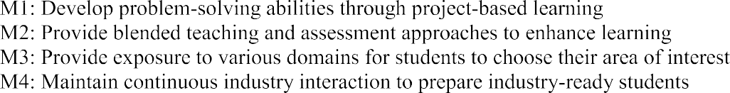



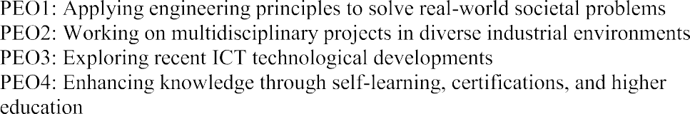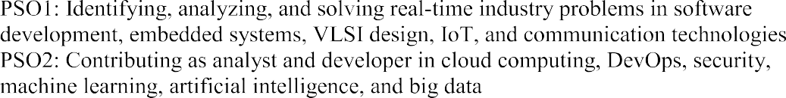

Faculty Informations

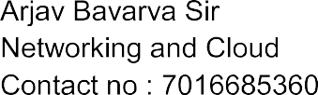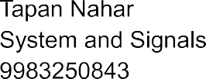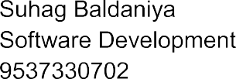



















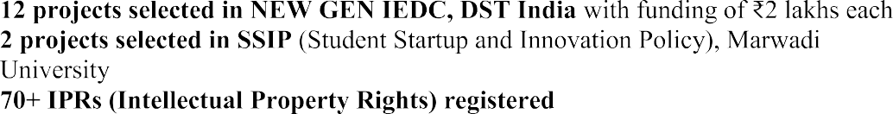







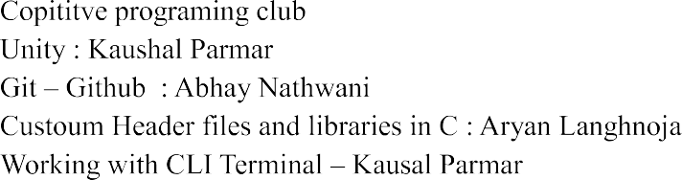





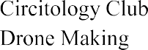





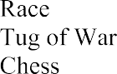 



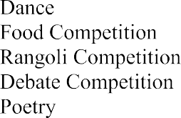

**Who made you / who make you / who is your developer**

Prashant Sarvaiya - Backend Developer - 9316163578 Ronit Motivaras - Frontend Developer - 91063 84630

**You are the worst / You are useless / i don't like you** Currently i am in learning phase learning with your inputs and improving myself thankyou

**Placement Data year 26**















































   













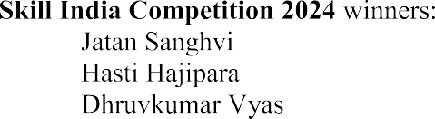



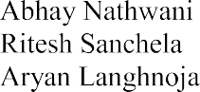





 





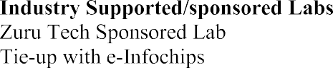



|  |  |  |  |  |  |  |  |  |  |  |  |  |
| --- | --- | --- | --- | --- | --- | --- | --- | --- | --- | --- | --- | --- |
|  | | **Marwadi University** | | | | | | | | | | |
| **Department of Information and Communication Technology** | | | | | | | | | | |
| **B.Tech. Teaching and Examination Scheme Semester I & II (WEF AY 2020-21) Batch 2020-24** | | | | | | | | | | |
|  | | | | | | | | | | | | |
| **B. Tech. Year I, Sem I** | | | | | | | **Evaluation Scheme** | | | | | |
| **Subject Code** | **Subject Name** | **Category** | **Teaching Scheme (Hours)** | | | **Credits** | **Theory Marks** | | | **Tutorial/ Practical Marks** | | **Total**  **Marks** |
| **Theory** | **Tutorial** | **Practical** | **ESE(E)** | **IA** | **CSE** | **Viva (V)** | **Term Work (TW)** |
| 01MA1101 | Differential and Integral Calculus | BSC | 4 | 2 | 0 | 5 | 50 | 30 | 20 | 25 | 25 | 150 |
| 01EE0104 | Electrical Circuits | ESC | 4 | 0 | 2 | 5 | 50 | 30 | 20 | 25 | 25 | 150 |
| 01EC0101 | Basics of Electronics Engineering | ESC | 3 | 0 | 2 | 4 | 50 | 30 | 20 | 25 | 25 | 150 |
| 01SL0102 /  01SL0103 | Reading & Writing for Technology /  Speaking & Presentation Skills | HSMC | 2 | 0 | 0 | 2 | 0 | 30 | 20 | 25 | 25 | 100 |
| 01CT0101 | Introduction to Computer Programming | ESC | 3 | 0 | 2 | 4 | 50 | 30 | 20 | 25 | 25 | 150 |
| 01CT0103 | Foundation skills in sensor interfacing | PROJ | 0 | 0 | 2 | 1 | 0 | 0 | 0 | 25 | 25 | 50 |
| 01CT0104 | ICT Workshop | PROJ | 0 | 0 | 2 | 1 | 0 | 0 | 0 | 25 | 25 | 50 |
| 01PE0101 | Physical Education/Sports/Yoga | MC-NCC | 0 | 0 | 2 | 0 | 0 | 0 | 0 | 0 | 0 | 0 |
|  | **Total** | **30** | **16** | **2** | **12** | **22** | **200** | **150** | **100** | **175** | **175** | **800** |
|  | | | | | | | | | | | | |
| **B. Tech. Year I, Sem II** | | | | | | | **Evaluation Scheme** | | | | | |
| **Subject Code** | **Subject Name** | **Category** | **Teaching Scheme (Hours)** | | | **Credits** | **Theory Marks** | | | **Tutorial/ Practical Marks** | | **Total**  **Marks** |
| **Theory** | **Tutorial** | **Practical** | **ESE(E)** | **IA** | **CSE** | **Viva (V)** | **Term work (TW)** |
| 01MA1151 | Matrix Algebra and Vector Calculus | BSC | 4 | 2 | 0 | 5 | 50 | 30 | 20 | 25 | 25 | 150 |
| 01EC0102 | Digital Electronics | ESC | 3 | 0 | 2 | 4 | 50 | 30 | 20 | 25 | 25 | 150 |
| 01ME0105 | Engineering Drawing and Computer Aided Design | ESC | 2 | 0 | 4 | 4 | 50 | 30 | 20 | 25 | 25 | 150 |
| 01CT0105 | Object Oriented Programming | PCC | 3 | 0 | 2 | 4 | 50 | 30 | 20 | 25 | 25 | 150 |
| 01EN0101 | Basics of Environmental Studies | ESC | 2 | 0 | 0 | 2 | 50 | 30 | 20 | 0 | 0 | 100 |
| 01CT0106 | Introduction to R and R Studio | PCC | 0 | 0 | 2 | 1 | 0 | 0 | 0 | 25 | 25 | 50 |
| 01CR0103 | Value Education | HSMC | 2 | 0 | 0 | 2 | 0 | 0 | 0 | 50 | 50 | 100 |
|  | **Total** | **28** | **16** | **2** | **10** | **22** | **250** | **150** | **100** | **175** | **175** | **850** |

|  |  |  |  |  |  |  |  |  |  |  |  |  |  |
| --- | --- | --- | --- | --- | --- | --- | --- | --- | --- | --- | --- | --- | --- |
|  | | **Marwadi University** | | | | | | | | | | | |
| **Department of Information and Communication Technology** | | | | | | | | | | | |
| **B.Tech. Teaching and Examination Scheme Semester III & IV (WEF AY 2021-22) Batch 2020-24** | | | | | | | | | | | |
|  | | | | | | | | | | | | | |
| **B. Tech. Year II, Sem III** | | | | | | | | **Evaluation Scheme** | | | | | |
| **Subject Code** | **Subject Name** | **Category** | | **Teaching Scheme (Hours)** | | | **Credits** | **Theory Marks** | | | **Tutorial/ Practical Marks** | | **Total**  **Marks** |
| **Theory** | **Tutorial** | **Practical** | **ESE(E)** | **IA** | **CSE** | **Viva (V)** | **Term Work (TW)** |
| 01MA0231 | Discrete Mathematics and Graph Theory | BSC | BS-UC | 4 | 2 | 0 | 5 | 50 | 30 | 20 | 25 | 25 | 150 |
| 01CT0301 | Computer Organisation and Architecture | PCC | PC | 3 | 0 | 2 | 4 | 50 | 30 | 20 | 25 | 25 | 150 |
| 01CT0302 | Signals and Systems | PCC | PC | 3 | 0 | 2 | 4 | 50 | 30 | 20 | 25 | 25 | 150 |
| 01CR0302 | Professional Ethics | HSMC | GN-UC | 1 | 0 | 0 | 1 | 0 | 0 | 0 | 50 | 50 | 100 |
| 01CT0303 | Introduction to Communication Engineering | PCC | PC | 3 | 0 | 2 | 4 | 50 | 30 | 20 | 25 | 25 | 150 |
| 01CT0308 | Data Structure using C++ | PCC | PC | 3 | 0 | 2 | 4 | 50 | 30 | 20 | 25 | 25 | 150 |
| 01CT0309 | Programming with Python | PROJ | EE | 0 | 0 | 2 | 1 | 0 | 0 | 0 | 25 | 25 | 50 |
|  | **Total** | **29** | **29** | **17** | **2** | **10** | **23** | **250** | **150** | **100** | **200** | **200** | **900** |
|  | | | | | | | | | | | | | |
| **B. Tech. Year II, Sem IV** | | | | | | | | **Evaluation Scheme** | | | | | |
| **Subject Code** | **Subject Name** | **Category** | | **Teaching Scheme (Hours)** | | | **Credits** | **Theory Marks** | | | **Tutorial/ Practical Marks** | | **Total**  **Marks** |
| **Theory** | **Tutorial** | **Practical** | **ESE(E)** | **IA** | **CSE** | **Viva (V)** | **Term work (TW)** |
| 01CT0401 | Probability and Statistics | PCC | IE | 3 | 2 | 0 | 4 | 50 | 30 | 20 | 25 | 25 | 150 |
| 01CT0403 | Microcontroller and Interfacing | PCC | PC | 3 | 0 | 2 | 4 | 50 | 30 | 20 | 25 | 25 | 150 |
| 01CT0404 | Analog and Digital Communication | PCC | PC | 3 | 0 | 2 | 4 | 50 | 30 | 20 | 25 | 25 | 150 |
| 01CT0407 | Database Management System | PCC | PC | 3 | 0 | 2 | 4 | 50 | 30 | 20 | 25 | 25 | 150 |
| 01CT0408 | Internet and Web Technology | PCC | PC | 3 | 0 | 2 | 4 | 50 | 30 | 20 | 25 | 25 | 150 |
| 01CT0409 | Operating System | PCC | PC | 3 | 0 | 2 | 4 | 50 | 30 | 20 | 25 | 25 | 150 |
|  | **Total** | **30** | **30** | **18** | **2** | **10** | **24** | **300** | **180** | **120** | **150** | **150** | **900** |

|  |  |  |  |  |  |  |  |  |  |  |  |  |
| --- | --- | --- | --- | --- | --- | --- | --- | --- | --- | --- | --- | --- |
|  | | **Marwadi University** | | | | | | | | | | |
| **Department of Information and Communication Technology** | | | | | | | | | | |
| **B.Tech. Teaching and Examination Scheme Semester V & VI (WEF AY 2022-23) Batch 2020-24** | | | | | | | | | | |
|  | | | | | | | | | | | | |
| **B. Tech. Year III, Sem V** | | | | | | | **Evaluation Scheme** | | | | | |
| **Subject Code** | **Subject Name** | **Category** | **Teaching Scheme (Hours)** | | | **Credits** | **Theory Marks** | | | **Tutorial/ Practical Marks** | | **Total**  **Marks** |
| **Theory** | **Tutorial** | **Practical** | **ESE(E)** | **IA** | **CSE** | **Viva (V)** | **Term Work (TW)** |
| 01CT0503 | Computer Networks | PCC | 3 | 0 | 2 | 4 | 50 | 30 | 20 | 25 | 25 | 150 |
| 01CT0512 | Design and Analysis of Algorithm | PCC | 3 | 0 | 2 | 4 | 50 | 30 | 20 | 25 | 25 | 150 |
| 01CT0513 | Digital Signal and Image Processing | PCC | 3 | 0 | 2 | 4 | 50 | 30 | 20 | 25 | 25 | 150 |
| 01CT0521 | Creativity, Problem Solving and Innovation | PROJ | 0 | 0 | 2 | 1 | 0 | 30 | 0 | 20 | 0 | 50 |
| 01GS0501 | Cognitive Aptitude -1 | HSMC-NCC | 2 | 0 | 0 | 0 | 0 | 0 | 0 | 0 | 0 | 0 |
| 01CT05XX | Department Elective - 1 | PEC | 4 | 0 | 2 | 5 | 50 | 30 | 20 | 25 | 25 | 150 |
| 01CT05XX | Department Elective - 2 | PEC | 4 | 0 | 2 | 5 | 50 | 30 | 20 | 25 | 25 | 150 |
|  | **Total** | **31** | **19** | **0** | **12** | **23** | **250** | **180** | **100** | **145** | **125** | **800** |
|  | | | | | | | | | | | | |
|  | **Department Electives 1, 2**   1. 01CT0507 - Advanced Microprocessor 2. 01CT0508 - Optical Communication 3. 01CT1509 - Linux Administration 4. 01CT1510 - Applied Linear algebra 5. 01CT0518 - .Net Technologies | | | | 1. 01CT0514 - VLSI Design 2. 01CT0516 - Engineering Electrodynamics 3. 01CT0515 - Information and Web Security 4. 01CT0519 - Machine Learning 5. 01CT0517 - Cross Platform Mobile Application Development | | | | | | | |
|  | | | | | | | | | | | | |
| **B. Tech. Year III, Sem VI** | | | | | | | **Evaluation Scheme** | | | | | |
| **Subject Code** | **Subject Name** | **Category** | **Teaching Scheme (Hours)** | | | **Credits** | **Theory Marks** | | | **Tutorial/ Practical Marks** | | **Total**  **Marks** |
| **Theory** | **Tutorial** | **Practical** | **ESE(E)** | **IA** | **CSE** | **Viva (V)** | **Term work (TW)** |
| 01CT0614 | Optimization Techniques | PCC | 3 | 0 | 0 | 3 | 50 | 30 | 20 | 0 | 0 | 100 |
| 01CT0615 | Software Engineering | PCC | 3 | 0 | 0 | 3 | 50 | 30 | 20 | 0 | 0 | 100 |
| 01CT0616 | Artificial intelligence | PCC | 3 | 0 | 2 | 4 | 50 | 30 | 20 | 25 | 25 | 150 |
| 01CT0617 | Human Centered Design | PROJ | 0 | 0 | 2 | 1 | 0 | 0 | 0 | 50 | 50 | 100 |
| 01CR0601 | Business Benchmark | HSMC | 1 | 0 | 0 | 1 | 0 | 0 | 0 | 50 | 50 | 100 |
| 01GS0601 | Cognitive Aptitude -2 | HSMC | 2 | 0 | 0 | 0 | 0 | 0 | 0 | 0 | 0 | 0 |
| 01CT06XX | Department Elective - 3 | PEC | 4 | 0 | 2 | 5 | 50 | 30 | 20 | 25 | 25 | 150 |
| 01CT06XX | Department Elective - 4 | PEC | 4 | 0 | 2 | 5 | 50 | 30 | 20 | 25 | 25 | 150 |
|  | **Total** | **28** | **20** | **0** | **8** | **22** | **250** | **150** | **100** | **175** | **175** | **850** |
|  | | | | | | | | | | | | |
|  | **Department Elective – 3, 4**   1. 01CT0618 - Sensors and IoT 2. 01CT0605 - RF and Microwave Communication 3. 01CT0611 - Cloud Computing 4. 01CT0621 - Computer Vision 5. 01CT0623 - Advanced Java 6. 01CT0625 - Advanced Web Technologies | | | | 1. 01CT0619 - Digital Design using Verilog 2. 01CT0610 - Satellite Communication 3. 01CT0627 - Cyber Security 4. 01CT0622 - Big Data Analytics 5. 01CT0624 - Theory of Computation 6. 01CT0626 - Game Programming and VR | | | | | | | |

|  |  |
| --- | --- |
|  | **Marwadi University** |
| **Department of Information and Communication Technology** |
| **B.Tech. Teaching and Examination Scheme Semester VII & VIII (WEF AY 2023-24) Batch 2020-24** |

|  |  |  |  |  |  |  |  |  |  |  |  |  |  |  |
| --- | --- | --- | --- | --- | --- | --- | --- | --- | --- | --- | --- | --- | --- | --- |
| **B. Tech. Year IV, Sem VII** | | | | | | | | | **Evaluation Scheme** | | | | | |
| **Subject Code** | **Subject Name** | **Category** | | | **Teaching Scheme (Hours)** | | | **Credits** | **Theory Marks** | | | **Tutorial/ Practical Marks** | | **Total**  **Marks** |
| **AICTE** | **CBCS** | **Skill** | **Theory** | **Tutorial** | **Practical** | **ESE(E)** | **IA** | **CSE** | **Viva (V)** | **Term Work (TW)** |
| 01CT0715 | Capstone Project | PROJ-ICT | EE | Skill | 0 | 0 | 6 | 3 | 0 | 0 | 0 | 50 | 50 | 100 |
| 01CT1702 | Information Theory and Coding | PCC - ICT | PC |  | 3 | 2 | 0 | 5 | 50 | 30 | 20 | 25 | 25 | 150 |
| 01CT0716 | Mobile and Pervasive computing | PCC - ICT | PC |  | 4 | 0 | 2 | 5 | 50 | 30 | 20 | 25 | 25 | 150 |
| 01CT0704 | Management Information System | HSMC | GN-UC |  | 3 | 0 | 0 | 3 | 50 | 30 | 20 | 0 | 0 | 100 |
| 01CT07XX | Department Elective – 5 | PEC - ICT | PEC | Skill | 3 | 0 | 2 | 4 | 50 | 30 | 20 | 25 | 25 | 150 |
| 01CT07XX | Department Elective – 6 | PEC - ICT | PEC | Skill | 3 | 0 | 2 | 4 | 50 | 30 | 20 | 25 | 25 | 150 |
|  | **Total** | **30** | | | **16** | **2** | **12** | **24** | **250** | **150** | **100** | **150** | **150** | **800** |
|  | | | | | | | | | | | | | | |
|  | **Department Elective - 5,6**   1. 01CT0717 - VLSI Physical Design 2. 01CT0719 - Adhoc Wireless Networks 3. 01CT0720 - Cloud Developing 4. 01CT0722 - Deep Learning 5. 01CT0724 - Compiler Design | | | | | | 1. 01CT0718 - FPGA Based System Design 2. 01CT0726 - Software Defined Networks 3. 01CT0721 - Blockchain 4. 01CT0723 - Information Retrieval and Natural Language Processing 5. 01CT0725 - Advanced Database | | | | | | | |
|  | | | | | | | | | | | | | | |
| **B. Tech. Year IV, Sem VIII** | | | | | | | | | **Evaluation Scheme** | | | | | |
| **Subject Code** | **Subject Name** |  | | | **Teaching Scheme (Hours)** | | | **Credits** | **Theory Marks** | | | **Tutorial/ Practical Marks** | | **Total**  **Marks** |
| **AICTE** | **CBCS** | **Skill** | **Theory** | **Tutorial** | **Practical** | **ESE(E)** | **IA** | **CSE** | **Viva (V)** | **Term work (TW)** |
| 01CT1801 | Project | PROJ-ICT | EE | Skill | 0 | 0 | 26 | 13 | 0 | 0 | 0 | 100 | 100 | 200 |
| 01CT08XX | Department Elective – 7 | PEC - ICT | PEC | Skill | 3 | 0 | 0 | 3 | 50 | 30 | 20 | 25 | 25 | 150 |
| 01CT08XX | Department Elective – 8 | PEC - ICT | PEC | Skill | 3 | 0 | 0 | 3 | 50 | 30 | 20 | 25 | 25 | 150 |
|  | **Total** | **32** | | | **6** | **0** | **26** | **19** | **100** | **60** | **40** | **150** | **150** | **500** |
|  | | | | | | | | | | | | | | |
|  | **Department Elective - 7,8 (MOOC)**   1. 01CT0818 - Analog Circuit Design 2. 01CT0814 - Spread spectrum communications 3. 01CT0828 - Cloud Architecture 4) 01CT0816 - Advance Machine Learning   5) 01CT0821 - Object Oriented Analysis and Design | | | 1. 01CT0819- RTOS 2. 01CT0820 - Introduction to 5G 3. 01CT0811 - Introduction to DevOps Tools 4. 01CT0817 - Advance Data Analytics 5. 01CT0822 - Soft Computing | | | | | 11)  01CT0823- Cloud Technical Essentials   1. 01CT0824 - Security Essentials 2. 01CT0825 - Machine Learning Essentials 3. 01CT0826 - Human Computer Interaction 4. 01CT0827 - Software Testing | | | | | |